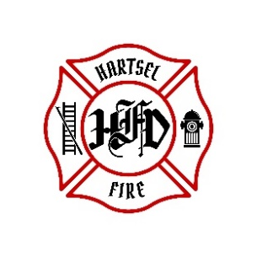

**HARTSEL FIRE PROTECTION DISTRICT**

**PENSION BOARD MEETING**

**October 11, 2024**

1. **CALL TO ORDER:**

**2. APPROVAL OF AGENDA:**

**3. APPROVAL OF PENSION MINUTES DATED: July 12, 2024**

**4. SIGN DOCUMENTS:**

**5. OLD BUSINESS:**

1. **2nd Quarter 2024 FPPA Allocation Report**

**6. NEW BUSINESS:**

**7. ADJOURNMENT:**

**POSTED 10/7/2024 @ H.F.P.D. HEADQUARTERS, WEBSITE** [**WWW.HARTSELFIRE.ORG**](http://WWW.HARTSELFIRE.ORG)