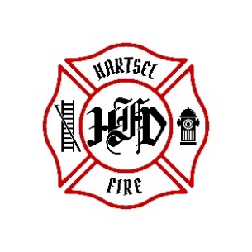
HARTSEL FIRE PROTECTION DISTRICT
PENSION BOARD MEETING

July 12, 2024

- CALL TO ORDER:

2. APPROVAL OF AGENDA:

3. APPROVAL OF PENSION MINUTES DATED: April 12, 2024

4. SIGN DOCUMENTS:

5. OLD BUSINESS:
- 1st Quarter 2024 FPPA Allocation Report
- Volunteer Pension Benefits

6. NEW BUSINESS:

7. ADJOURNMENT:

POSTED 7/8/2024 @ H.F.P.D. HEADQUARTERS, WEBSITE WWW.HARTSELFIRE.ORG

