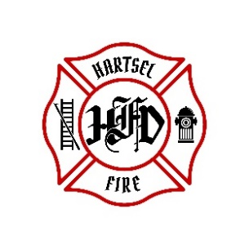

**HARTSEL FIRE PROTECTION DISTRICT**

**BOARD MEETING AGENDA**

**January 5, 2024**

1. **CALL TO ORDER:**
2. **PLEDGE OF ALLEGIANCE**
3. **APPROVAL OF AGENDA:**
4. **CITIZENS COMMENTS / GUEST SPEAKERS:**
5. **BOARD CONCERNS / COMMENTS:**
6. **APPROVAL OF BUDGET**

1. **ADJOURNMENT:**

**POSTED 1/2/2024 @ H.F.P.D. HEADQUARTERS, WEBSITE** [**WWW.HARTSELFIRE.ORG**](http://WWW.HARTSELFIRE.ORG)