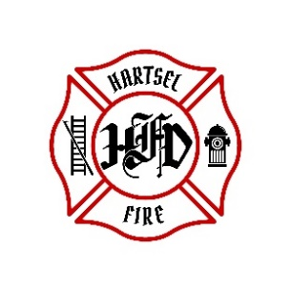

**HARTSEL FIRE PROTECTION DISTRICT**

**BOARD MEETING AGENDA**

**January 17, 2025**

1. **CALL TO ORDER:**
2. **PLEDGE OF ALLEGANCE**
3. **APPROVAL OF AGENDA:**
4. **SWEARING IN: WELCOME NEW FIREFIGHTERS**
5. **CITIZENS COMMENTS / GUEST SPEAKERS: (Limit to 3 minutes per speaker)**
6. **APPROVAL OF MINUTES DATED December 13th, 2024**
7. **BOARD CONCERNS / COMMENTS:**
8. **FINANCIALS:**
   1. **Accept Financials**
   2. **Approve Bills**
   3. **Approve Fund Transfers**
   4. **Sign Documents / Checks**
9. **FACILITY EQUIPMENT REPORT**
10. **CHIEF’S REPORT:**
    1. **Calls to Date: 2024 ________, 2025 _______2024 Year end________**
    2. **Impact Fees to Date: 2024_______, 2025_______**
11. **OLD BUSINESS:**
    1. **Rosenbauer Update**
12. **NEW BUSINESS:**
    1. **Volunteer Point System**
13. **ADJOURNMENT:**

**POSTED 1/9/2025 @ H.F.P.D. HEADQUARTERS, WEBSITE** [**WWW.HARTSELFIRE.ORG**](http://WWW.HARTSELFIRE.ORG)