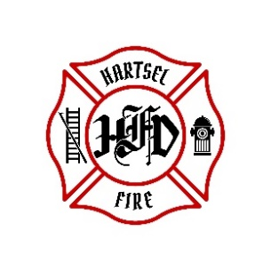

**HARTSEL FIRE PROTECTION DISTRICT**

**PENSION BOARD MEETING**

**January 17, 2025**

1. **CALL TO ORDER:**

**2. APPROVAL OF AGENDA:**

**3. APPROVAL OF PENSION MINUTES DATED: October 11, 2024**

**4. SIGN DOCUMENTS:**

**5. OLD BUSINESS:**

1. **3rd Quarter 2024 FPPA Allocation Report**

**6. NEW BUSINESS:**

1. **Required Volunteer Shifts**

**7. ADJOURNMENT:**

**POSTED 1/9/2025 @ H.F.P.D. HEADQUARTERS, WEBSITE** [**WWW.HARTSELFIRE.ORG**](http://WWW.HARTSELFIRE.ORG)