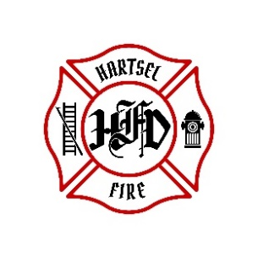
HARTSEL FIRE PROTECTION DISTRICT
BOARD MEETING AGENDA

May 10th, 2024

- CALL TO ORDER:

- PLEDGE OF ALLEGANCE

- APPROVAL OF AGENDA:

- CITIZENS COMMENTS / GUEST SPEAKERS:

- APPROVAL OF MINUTES DATED: April 12th, 2024

- BOARD CONCERNS / COMMENTS:

- FINANCIALS:
  - Accept Financials
  - Approve Bills
  - Approve Fund Transfers
  - Sign Documents / Checks

- FACILITY EQUIPMENT REPORT

- CHIEF’S REPORT:
  - Calls to Date: 2023 ________, 2024 _______
  - Impact Fees to Date: 2023_______, 2024_______

- OLD BUSINESS:
  - Policies
  - Election

- NEW BUSINESS:
  - FPPA Volunteer Plan Affiliation Agreement
  - Command Truck

- ADJOURNMENT:

POSTED 5/1/2024 @ H.F.P.D. HEADQUARTERS, WEBSITE WWW.HARTSELFIRE.ORG

